Title: | Door Control Module GOC Motors Automotive  SW Architecture Door_Control

History
Issue status  (Index) | Maturity/Date  (draft/invalid/valid)  (dd-mmm-yyyy) | Author  Department | Check/Release  Department | Description
1.0 | Draft  26-Ago-21 | Marco Granados | Marco Granados | Creation of the document

Table of Contents
1 Purpose 3
2 Definitions and abbreviations 3
3 Realization constraints and targets 3
4 SW Functional Architecture 3
4.1 Table of functions 3
4.2 Table of functional Interfaces 4
4.3 Functional Interface 4
4.4 Functional Interaction 4
5 SW Physical Architecture 5
5.1 Physical Decomposition 5
5.2 Table of SW components 5
5.3 Table of Physical Interfaces 5
5.4 Physical Interfaces 6
5.5 Physical Interaction 6
5.6 Describe Dynamic Behavior 6
5.6.1 OS tasks 6
5.6.2 Interrupt Handling 6
5.6.3 Power Modes 7
5.7 Synchronization Mechanisms 7
6 Function to Physical Allocation 7
7 SW Requirements Allocation 8
8 SW Integration Plan 8
9 Functional Safety 8

Purpose
This document has been created as a demonstration to the students about to how to create a SW architecture from requirements.

Definitions and abbreviations
Definitions
Special Byte | Special byte received to change the baud rate 55h

Abbreviations
Only SW Architecture specific abbreviations.
SW
DID
NVM
HW
References
N° | Document name | Reference
1 | SW Requirements

Realization constraints and targets

An overview of which are the goals that must be achieved with these functionalities.
The targets that we have is provide comfort to the user

SW Functional Architecture
Identify the functional behavior that will be implemented on Software.
Identify different SW functions with its corresponding interaction among them.
Identify and describe the signals and events used to share information among functions.

Table of functions
Function Name | Description
Press Button | All Button shall to be the condition assigned
Power Module | All Voltages shall to be the value assigned
Manufacturing_Info | All shall be manufacture
Timer | All shall be respect the timer
Manager Error | All shall be report to the manager_Report and will be evaluated

Table of functional Interfaces
Signal/Event | Description
Button_Manager | All Input shall be analogic from the systems
Manufacturing_Info | All shall be manufacture
Memory_Service | All shall save the data
Power_Manager | All Voltages shall to be the value assigned
Driver | All drivers should be used

Functional Interface
Display on a static way the interfaces among SW functions. Block Definition diagram and/or Activity diagram are recommended to describe those interfaces. Include a description for every Diagram included on this section.
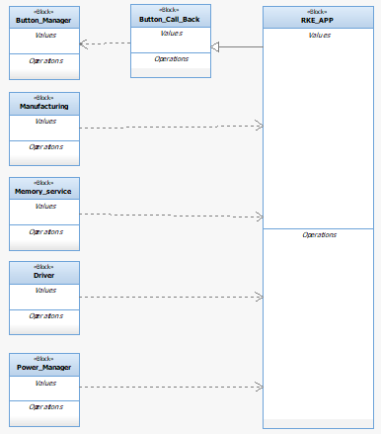
Illustration 1.

Functional Interaction
Display on a dynamic way the interaction among SW functions. Sequence Diagram and/or Timing diagrams are recommended to describe those interactions. Include a description for every Diagram included on this section.

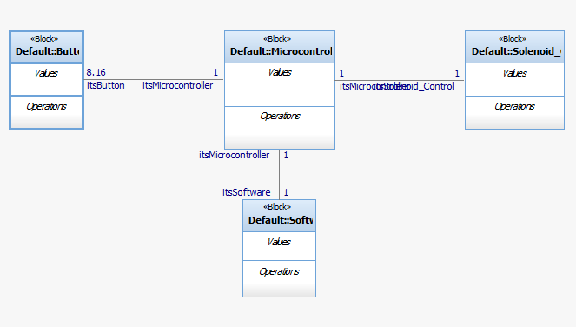
Ilustración 2.

SW Physical Architecture
Define Physical architecture that will be implemented on Software with its corresponding SW decomposition.
Identify different SW Components with its corresponding interaction among them.
Identify and describe the signals and events used to share information among SW Components.
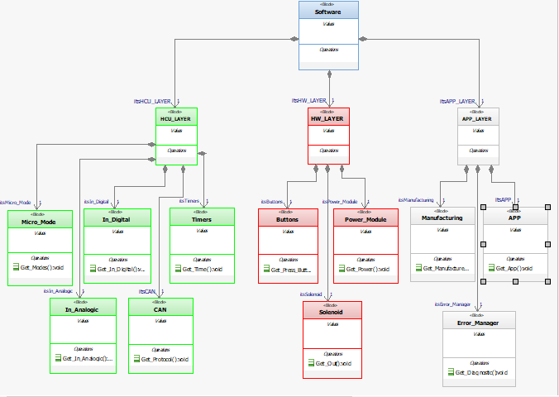
Illustration 3.

Physical Decomposition
Include a Block Definition Diagram and describe the SW Decomposition. Indicate its estimated size in KB.
Illustration 4.

Table of SW components
SWC Name | Description | Estimated Size (KB)
RKE_APP | Organize the interface | 4kb
Stdio | Macros Definition | 2kb
Error_Manager | Analysis about the error | 5kb
Learning_Manager | Analysis about the system | 6kb
Manufacturing_info | Information about the manufacture | 5kb

Table of Physical Interfaces
Operation | Description
Button Manager | Input Analogics
Manufacturing | Information about the manufacture
Button Call back | Action apropiate per button
Memory service | Save data
Driver manager | Driver master
Power Manager | All Voltages shall to be the value assigned

Physical Interfaces
Display on a static way the interfaces among SW components. Block Definition diagram and/or Activity diagram are recommended to describe those interfaces. Include a description for every Diagram included on this section.
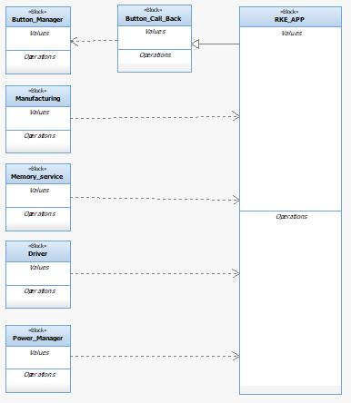
Illustration 5.

Physical Interaction
Display on a dynamic way the interaction among SW components. Sequence Diagram and/or Timing diagrams are recommended to describe those interactions. Include a description for every Diagram included on this section.
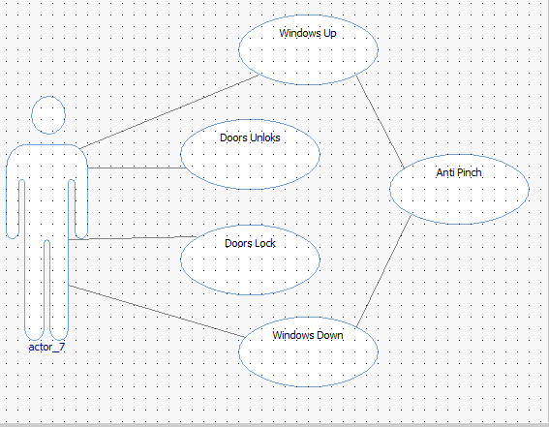
Illustration 6.

Describe Dynamic Behavior
This chapter shall be used to describe at physical level the runtime behavior of the SW.

OS tasks
OS task | Description | Periodicity | Period | Priority | CPU Load
Read Inputs  Analogic | Pressing buttons |  |  | medium | 2%
Read  Inputs  Digital | Transform analogic to digital data |  |  | medium | 2%
Comunication | Between modules |  |  | high | 3%
Power_Manager | Administration Voltages |  |  | high | 5%
Error_Manager | Searching Errors and datas |  |  | high | 10%

Interrupt Handling
ISR task | Description | Priority | CPU Load
Press Unlock/Lock | Pressing both button, it will be considered off | high | 1%
Open/close window | All shall be off when the vehicle is turn off | medium | 1%

Power Modes

Low Power Mode
Describe in this chapter the operation, functions and resources that will be executed during Low Power Mode. Identify what are the wakeup sources and list them on this section.
Keep the Power_Module off for avoid Accidents when is no use.

High Power Mode
Describe in this chapter the operation, functions and resources that will be executed during High Power Mode. Identify what are the Low Power Mode conditions and list them on this section.
Keep synchronized and turn on all moment.

Synchronization Mechanisms
Describe Mechanism used to synchronize process like critical sections, semaphore, mutex, priority ceiling, etc.
The System will be synchronized with the timer.

Function to Physical Allocation
Perform the allocation of function to a SW component. One function shall be allocated to one SW component (if this cannot be achieved indicate a clarification wich part of the function shall be allocated to every SW component). One SW component might have
Function | SW component | Clarification
Input analogic | Button_Manager | medium
Manufacturing | Manufacturing_Manager | medium
Power module | Power_Module | high
Send data | Error_Manager | medium
Memory Service | Memory_Service | medium

SW Requirements Allocation
Indicates the requirements that will be implemented for every SW component. Use the requirements IDs from Traceability Matrix.
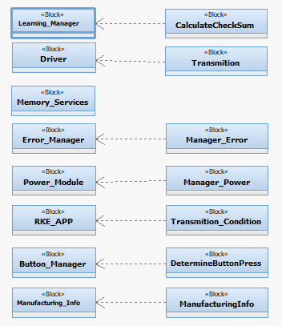
Illustration 7.

SW Integration Plan
Identify the dependencies for SW construction. Identify hierarchy for implementation. Indicate the integration steps for SW construction.

Integration Step | Description | SW components | Comments
1 | Input analogics will be Convert to Digital and sending to microcontroller | Button_Manager
2 | Analysis about the system | Learning_Manager
3 | Compare data and send information about the error | Error_Manager

Functional Safety
This chapter will be fill during Module 5

